1st. VIRGINIA CMSA Membership Application and Renewal
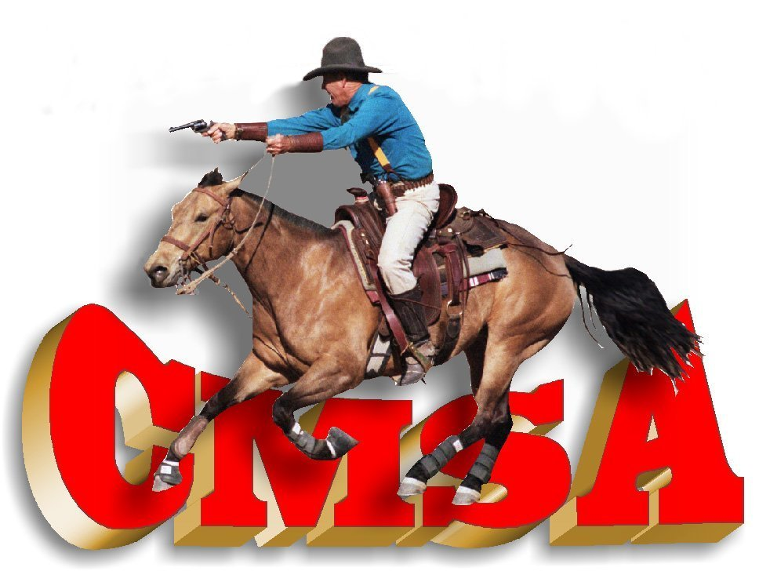
21867 Genito Road, Amelia, Virginia 23002
Email: cmsa1stvirginia@gmail.com
Date: _________ Membership Year: ________
Name | CMSA# | Level | Date of Birth | Email Address
Level: Men’s 1,2,3,4,5,6 Ladies 1,2,3,4,5,6 Wrangler Limited (up to age 10) Wrangler Open (ages 11 and 12)
Senior (age 50 and over) Senior Men’s 1,2,3,4,5,6 Senior Ladies 1,2,3,4,5,6
Address: ________________________________
City: ____________________________ State: ____ Zip: _________
Daytime Phone (____) ______________ Other Phone (____) _____________
Emergency Contact: (Name & Phone): ______________________________________________
CMSA annual membership includes receipt of Competition Card(s), 1 Decal, 1 Rulebook, 1 Course book, and a 1-year subscription to the “CMSA Rundown” magazine. Family Membership covers all members living in one household. CMSA annual membership is 365 days. Membership is active beginning one year prior to the expiration date on the membership card. Example: Join Oct 31, 2017, membership will expire on Oct 31, 2018. Membership options are:
Membership Type | Amount due | Home club
1st Virginia CMSA membership | $ 50.00
1st Virginia CMSA and CMSA membership | $120.00
Family membership 1st Virginia CMSA | $ 75.00
Family Membership 1st Virginia and CMSA | $175.00
Associate Card | $ 35.00
Life Competition Card (CMSA only) | $450.00
CMSA membership only | $ 70.00
CMSA Family membership only | $100.00
***I wish to make a tax-deductible donation to the CMSA 501c Scholarship fund in the amount of $_________***
***Participation in a minimum of 50 % of scheduled 1st Virginia CMSA events is required to be eligible for end-of-year awards.
***If joining as a new 1st VA CMSA member after June 1st, membership will be good for the remainder of the current season (through the CMSA Worlds Championship in the month of October), and the following season.
***1st VA CMSA recommends that all participants wear a helmet when mounted.

Signature Required on Attached Release Form

COWBOY MOUNTED SHOOTING ASSOCIATION
PARTICIPATION AND RELEASE AGREEMENT
Contestant’s Name___________________________________________________________
As a Contestant, I understand that I am participating in a sport which contains danger and potential risks, including those associated with equine and gun related activities, as both a participant and a spectator. In consideration of the opportunity to observe and/or participate in this sport, I agree as follows:
1. Contestant agrees that CMSA and its sponsors, may use photographs, videos, images and other recordings of Contestant, his/her horse and equipment for educational, marketing and other promotional purposes, without compensation to Contestant.
2. Contestant agrees to support and enforce CMSA rules, as stated in the CMSA rulebook, as may be amended and any interim rules that may be adopted by CMSA. Adherence to this policy will bind all CMSA cardholders to enforce CMSA rules and to assure equality of competition across the United States.
3. Contestant agrees not to make any claim against Cowboy Mounted Shooting Association (“CMSA”) or 1st Virginia CMSA for any indemnification, damages, or personal injury sustained.
Contestant must initial here: _________________
4. In the event Contestant’s Conduct or omissions should result in injury to persons or damage to property, Contestant shall indemnify and hold harmless CMSA, its members, shareholders, partners, associates, employees, sponsors, officers, agents, attorneys, and any individuals and entities associated therewith, from any all claims, suits, liabilities, losses, judgments, costs or expenses, including attorneys’ fees, that they, or any of them, may at any time incur, or might arise, relating to Contestant’s acts or omissions.
5. Any claim, action or dispute of any nature whatsoever against or involving CMSA, or arising out of or in any way relating to this Release, shall be resolved in Roswell, NM where CMSA is headquartered. This Release shall be interpreted, construed, and enforced in Accordance with the laws of the State of New Mexico.
6. In the event that any provision or portion of the Participation and Release Agreement (“Release”) are determined to be unenforceable, the remainder of this Release shall not be affected thereby and each remaining provision or portion thereof shall continue to be valid and effective and shall be enforceable to the fullest extent permitted by law.
Contestant hereby acknowledges by signing below that he/she has read and fully understands the foregoing provisions.
Contestant’s Signature ____________________________________________ Date ___________________
Name(s) of Contestant’s Under Age 18 ___________________________________________________
___________________________________________________
___________________________________________________
___________________________________________________
(Parental or Guardian Signature for Contestant’s Under Age 18)____________________________________

